*Ref: 92439*

Loddiswell, Kingsbridge, Devon, TQ7 4RS

Kingsbridge 3 miles; A38 Devon Expressway 7 miles; Totnes 12 miles

An extended 3 double bedroom, 2 bathroom village property having accommodation arranged over 3 floors with sheltered garden, parking and glorious far reaching countryside views. EPC Rating D

**£850 PCM**

Contact Lettings 01548 855599



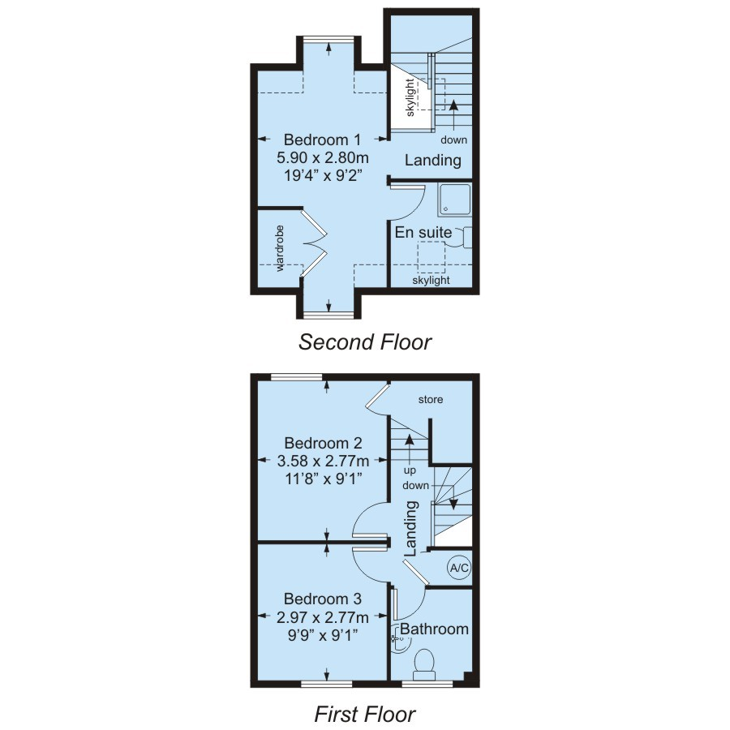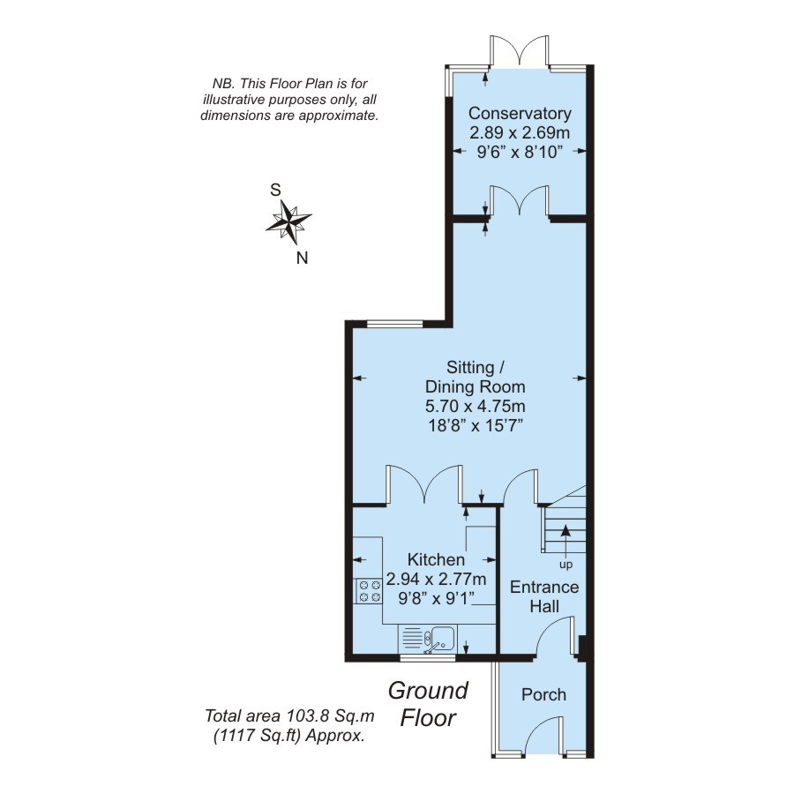

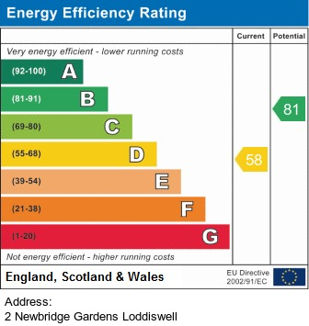

Error: Object reference not set to an instance of an object.

Loddiswell, Kingsbridge, Devon, TQ7 4RS

**SITUATION AND DESCRIPTION**

Loddiswell is a popular village with a thriving community located within easy reach of the A38 Devon Expressway and just over 3 miles from the market town of Kingsbridge. The village has its own general store, post office/handy shop, pub, primary school and church. Loddiswell is surrounded by unspoilt rolling countryside with interesting river walks and is within easy reach of the beautiful coastline, beaches and estuaries of the South Hams. Within a mile of the property is the popular Avon Mill Garden Centre with deli and cafe and the Aune Valley Farm Shop.

Located in a quiet and elevated position of this popular Kingsbridge village, 2 New Bridge Gardens has been well appointed throughout to provide a spacious family home. The property benefits from 3 double bedrooms with the master en-suite located on the top floor and featuring a sloping painted timber clad ceiling with 2 further bedrooms and a family bathroom on the 1st floor. The ground floor has been extended to provide a kitchen with breakfast bar, a generous living room and dining area as well as a beautifully presented conservatory with French doors. The southerly facing garden doesnt disappoint with manicured lawns and individual sun spots and al fresco dining areas including a timber deck. Privately enclosed with trellis fencing.

**The ACCOMMODATION comprises:-**

**ENTRANCE PORCH**

Opening into:-

**ENTRANCE HALL**

Staircase rising to first floor. Wood laminate flooring. Night storage heater.

**SITTING / DINING ROOM**

An L-shaped room having window to rear aspect. Dado rail. Two night storage heaters.

**KITCHEN**

Range of floor and wall based cupboards. One and a half bowl stainless steel sink set in roll edge worksurface, tiled splashback. Integrated electric oven and hob, extractor hood and light above. Integrated dishwasher. Space and plumbing for washing machine, space for fridge/freezer. Breakfast bar. Night storage heater. Wood laminate flooring. Window.

**CONSERVATORY**

French doors opening to garden with windows to rear and side. Vinyl tiled flooring.

**FIRST FLOOR LANDING**

Stairs rising to second floor. Built in airing cupboard with factory lagged hot water cylinder.

**BEDROOM 2**

Double bedroom with window to rear aspect enjoying views over the village to surrounding countryside. Electric panel heater. Under stairs storage cupboard.

**BEDROOM 3**

Double bedroom with window to front aspect having lovely far reaching views over Loddiswell and the Avon Valley. Electric panel heater.

**FAMILY BATHROOM**

White suite comprising bath, pedestal wash hand basin, WC. Obscure glazed window. Extractor fan. Vinyl tiled flooring.

**SECOND FLOOR LANDING**

Part sloping ceiling with Velux skylight. Loft hatch.

**MASTER BEDROOM**

Part sloping ceiling with windows to front and rear aspects affording wonderful views across Loddiswell to unspoilt farmland beyond. Electric panel heater. Built in wardrobe.

**EN-SUITE SHOWER ROOM**

Fully tiled shower cubicle fitted with an electric shower. WC. (Plumbing for wash hand basin). Part sloping ceiling, Velux skylight. Electrically heated towel rail. Painted exposed floorboards. Extractor fan.

**REAR GARDEN**

South facing garden which has been laid to lawn with planted shrubs. Gravelled seating area, timber decked barbeque area.

**OUTSIDE**

The property is approached over a brick paved path leading to the porch. The remainder of the front garden has been gravelled with planted shrubs. Allocated parking space for two cars.

**SERVICES**

Mains water, drainage and electricity. Electric heating.

**COUNCIL TAX**

Currently Band .

**LOCAL AUTHORITY**

South Hams District Council, Follaton House, Plymouth Road, Totnes, Devon TQ9 5NE. Tel: 01803 861234.

**POST CODE**

TQ7 4RS.

**FIXTURES AND FITTINGS**

All items in the written text of these particulars are included in the sale. All others are expressly excluded regardless of inclusion in any photographs. Purchasers must satisfy themselves that any equipment included in the sale of the property is in satisfactory order

**VIEWING**

Strictly by appointment with the agent, Marchand Petit Lettings. Tel. 01548 855599.

**AVAILABLE**

January 2017

**DIRECTIONS**

From Kingsbridge head northwards towards the village of Loddiswell, which is approximately 3 miles away. Enter the one way system and opposite the primary school turn left into Arundell Road and then left again, the property will be found on the right hand side.

**Administration Fees:**

One adult application £150. Two adult applications £300. Each additional adult application £150. Each guarantor £48. Check out fee £90. Should you wish to make any alterations to the terms and conditions already agreed, including changing the tenancy commencement date, which will necessitate amended documentation to be provided, an administration charge of £60 will apply.

Pets - if the landlord gives permission for pets to be kept at the property, an additional deposit, from £250, will be requested according to the requirements of the landlord and the number and size of the pets being kept at the property.

